**DAILY ONLINE ACTIVITIES SUMMARY**

|  |  |  |  |  |  |  |  |  |
| --- | --- | --- | --- | --- | --- | --- | --- | --- |
| **Date:** | **10-06-2020** | | | | | **Name:** | **Nihal Rafiq** | |
| **Sem & Sec** | **4th A** | | | | | **USN:** | **4AL18CS052** | |
| **Online Test Summary** | | | | | | | | |
| **Subject** | | **Object Oriented Concept** | | | | | | |
| **Max. Marks** | | **30** | | **Score** | | | **02** | |
| **Certification Course Summary** | | | | | | | | |
| **Course** | **Data Visualization using Python** | | | | | | | |
| **Certificate Provider** | | | **Great Learning Academy** | | **Duration** | | | **2 hours** |
| **Coding Challenges** | | | | | | | | |
| **Problem Statement:**  **1. Write a C program to print the sum of boundary elements of a matrix**  **2. Write a java program to find the longest repeating sequence in a string** | | | | | | | | |
| **Status: Executed** | | | | | | | | |
| **Uploaded the report in Github** | | | | | **Yes** | | | |
| **If yes Repository name** | | | | | **https://github.com/nihal-art/lockdown-coding** | | | |
| **Uploaded the report in slack** | | | | | **Yes** | | | |

Online test details:

Test was on 3rd and 4th module of OOC (18CS45). The duration of the test was 30 minutes from 09:15am to 09:45am. Questions were of multiple choice and the questions were based on programming. Score I received is 02/30. Due to technical issue, I wasn’t able to attend test.

Certification Course Details:

I have opted for Data Visualization using Python.

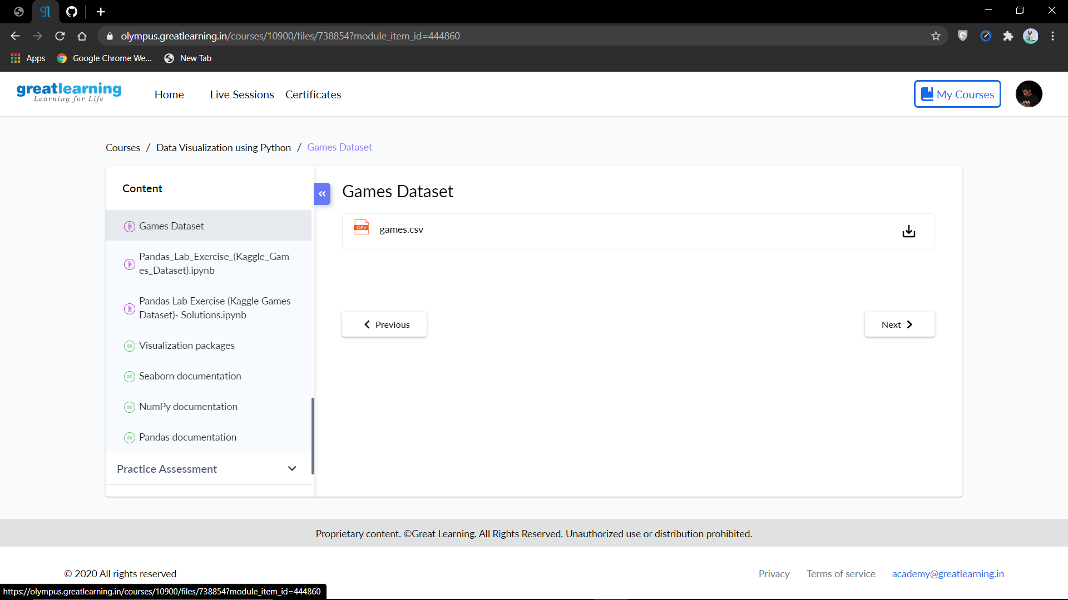

Coding Challenges Details:

1. Write a C program to print the sum of boundary elements of a matrix. Given a matrix, the task is to print the boundary elements of the matrix and display their sum

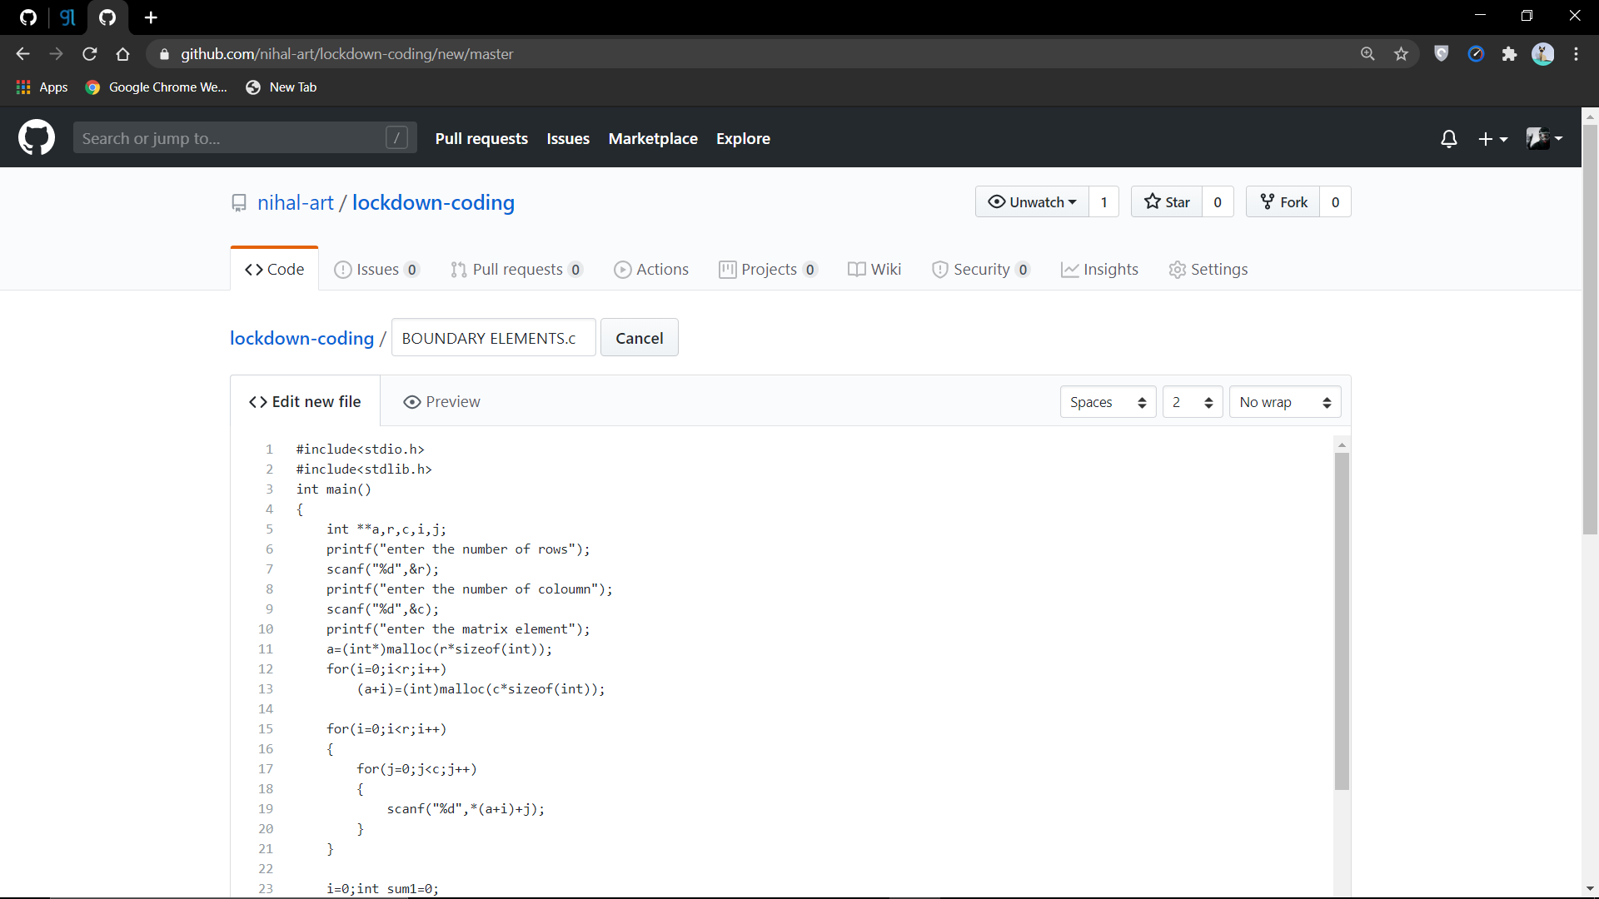

2. Write the java program to find the longest repeating sequence in a string.string:acbdfghybdf

